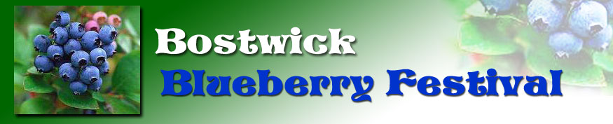 Cook-off 2019
Please print clearly

Recipe Title: ___________________________________________
Cook's Name: __________________________________________
Address: ______________________________ State ______ Zip ________
Phone Number: _____________________ Email Address: ___________________________________
Please note your remaining entry will be donated to the Blueberry Cafe. All proceeds from the cafe go to the many organizations and entities that benefit the Bostwick community. Thank you.
Signature________________________________________

Please submit this form and a complete recipe, clearly written, with your ingredient list and instructions, to the Cooking Contest registration table with your entry. All entries must be made by the non-professional cook entering it and must include blueberries.

For Office Use Only:

Place: _______ Entry Title: ___________________________ Entry #____ Youth___ Adult___

Cook-Off Rules

Blueberry Cook-off Contest is held Friday April 26, 2019. Entries must be made by the non-professional entrant and must include blueberries. Cooks must include the recipe and official entry form with their entry and their name may not be visible on the container. Please use a container that is disposable. Cook-off entries will be accepted Friday April 26th at Bostwick Baptist Church Fellowship Hall from 5:00 PM- 6:00 PM. Judging will be Friday from 6:30-7:00 PM and winners will be announced afterwards.
There will be two divisions:
Youth which shall consist of all entries made by a person aged 17 or younger
Adult which shall consists of all entries made by a person ages 18 or older

Judges for the 2019 Contest: To be announced.

